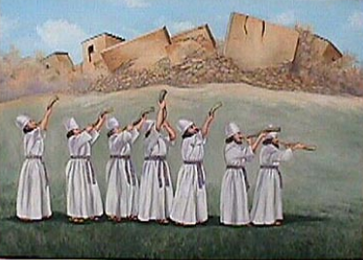



God Gives us the Victory But We have to Follow His Instructions

Joshua 6

1. **God Gives us the Victory!**

Jos 6:1 ¶ Now Jericho was straitly shut up because of the children of Israel: none went out, and none came in. 2 And the LORD said unto Joshua, See, I have given into thine hand Jericho, and the king thereof, and the mighty men of valour.

1. **Not a Sound for Almost 7 Days!**

6 ¶ And Joshua the son of Nun called the priests, and said unto them, Take up the ark of the covenant, and let seven priests bear seven trumpets of rams' horns before the ark of the LORD. 7 And he said unto the people, Pass on, and compass the city, and let him that is armed pass on before the ark of the LORD 8 And it came to pass, when Joshua had spoken unto the people, that the seven priests bearing the seven trumpets of rams' horns passed on before the LORD, and blew with the trumpets: and the ark of the covenant of the LORD followed them. 9 And the armed men went before the priests that blew with the trumpets, and the rereward came after the ark, the priests going on, and blowing with the trumpets **10 And Joshua had commanded the people, saying, Ye shall not shout, nor make any noise with your voice, neither shall any word proceed out of your mouth, until the day I bid you shout; then shall ye shout.** 11 So the ark of the LORD compassed the city, going about it once: and they came into the camp, and lodged in the camp.

12 And Joshua rose early in the morning, and the priests took up the ark of the LORD.

13 And seven priests bearing seven trumpets of rams' horns before the ark of the LORD went on continually, and blew with the trumpets: and the armed men went before them; but the rereward came after the ark of the LORD, the priests going on, and blowing with the trumpets.

14 And the second day they compassed the city once, and returned into the camp: so they did six days.

1. **A Great Shout for the Lord! For He Can Do Great Miracles – Praise God!**

15 And it came to pass on the seventh day, that they rose early about the dawning of the day, and compassed the city after the same manner seven times: only on that day they compassed the city seven times. 16 And it came to pass at the seventh time, when the priests blew with the trumpets, Joshua said unto the people, Shout; for the LORD hath given you the city.

20 So the people shouted when the priests blew with the trumpets: and it came to pass, when the people heard the sound of the trumpet, and the people shouted with a great shout, that the wall fell down flat, so that the people went up into the city, every man straight before him, and they took the city.

1. **God Said Destroy the City not keep its things!**

18 And ye, in any wise keep yourselves from the accursed thing, lest ye make yourselves accursed, when ye take of the accursed thing, and make the camp of Israel a curse, and trouble it.

CONCLUSION

27 So the LORD was with Joshua; and his fame was noised throughout all the country.